**File Permissions – 1**

● File permissions (file modes) specify who can access, change or execute a file on a Linux System.

● It ensures that only authorized users and processes can access files and directories.

● Each file or directory has an owner and a group. By default, the owner is the user who creates the file and the group is the primary group of that user.

● The ownership of a file or a directory can be changed only by root using the chown and chgrp commands.

**For each file the permissions are assigned to three different categories of users:**

1. The file owner.

2. The group owner.

3. Others (anyone else or the whole world).

**File Permissions – 2**

There are three file permissions types that apply to each category:

● The read permission (r)

● The write permission (w)

● The execute permission (x) To view the files permission run: ls -l or stat.

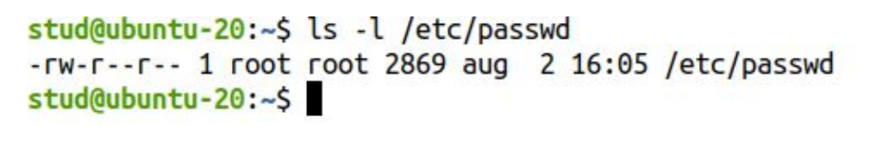

* We use **ls –l** to check the permission

**The Octal Notation**

● The number that represents the permission in base-8 can be a either a 3 or a 4-digit number with digits from 0 to 7. The leading zero (0) can be omitted.

● 0755 = 755 and 0644 = 644.

● When a 3 digit number is used, the first digit represents the permissions of the file’s owner, the second one the file’s group, and the last one the permissions of the others class.

● r, w, and x have their own fixed number value:

○ r (read) = 4

○ w (write) = 2

○ x (execute) = 1

○ - (no permissions) = 0

○ The permissions number of a specific user class is represented by the sum of the values of the permissions for that group.

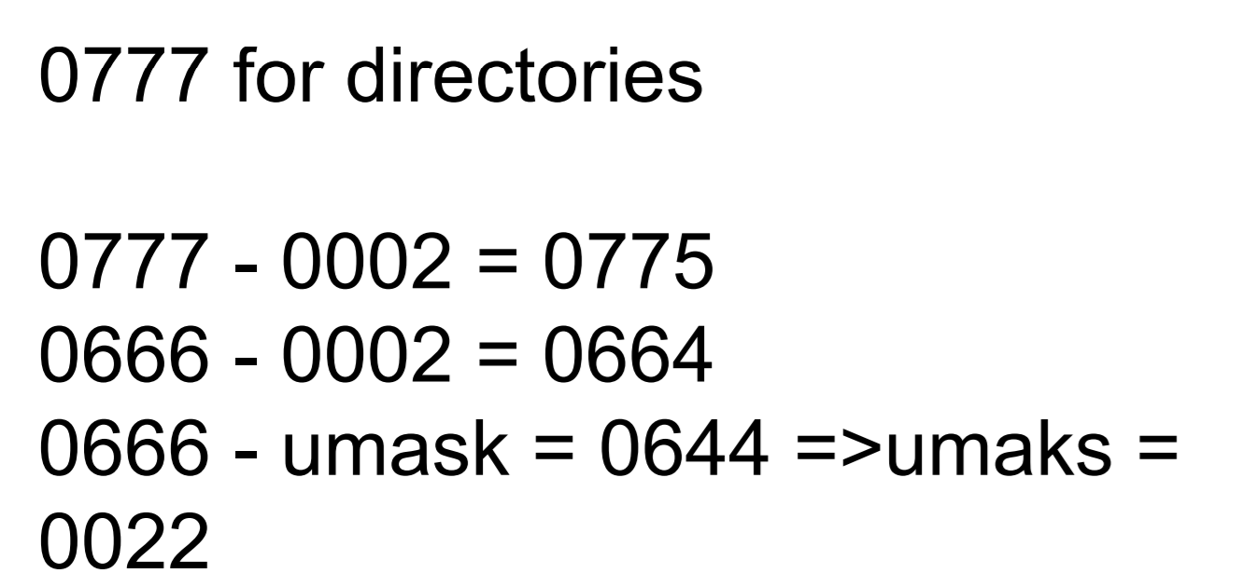

**Changing File Permissions (chmod)**

● chmod is the command used to change the permissions of a file or a directory using either the symbolic or the numeric notation.

● Only the root, or the file’s owner, can change the file’s permissions. chmod [who][OPERATION][permissions] filename.

**Changing File Permissions (chmod)**

chmod [who][OPERATION][permissions] filename

who signifies the user category whose permissions will be changed.

● u: the user that owns the file.

● g: the group that the file belongs to.

● o: the other users.

The OPERATION flags define whether the permissions are to be removed, added, or set:

● - : a hyphen means remove the specified permissions.

● + : the plus sign means Add the specified permissions.

● = : equals means change the current permissions to the specified permissions.

The permissions are specified using the letters r, w and x.